Lab – Page Object Model (POM)
Objective
This exercise will guide you through setting up the project, writing the POM classes, and creating test cases to test a sample application. In this exercise you will follow a step-by-step exercise to create a Selenium Page Object Model (POM) in Java using Eclipse.

What is a POM class?
Is a class in the Page Object Model (POM) design pattern used in Selenium for automating web application testing. Each web page of the application is represented as a class file. This class contains the web elements of that page and the methods to interact with them. POM classes greatly improve code maintenance and readability.
In this lab you will write tests for a simple Login page https://txmike2.glitch.me/login
Here is the HTML code for the page you will be testing:
<!DOCTYPE html>
<html>
<head>
<title>Login Page</title>
<script src="JavaScript1.js"></script>
</head>
<body>
<form id="loginForm" onsubmit="return validate()">
<label for="username"> Username:</label>
<input type="text" id="username" name="username"> <br />
<label for="password"> Password:</label>
<input type="password" id="password" name="password"> <br />
<button type="submit" id="login"> Login</button>
</form>
</body>
</html>

The username and password are validated before the form is submitted.

- Username must be greater than 2 chars
- Username must not contain numbers
- Password must be greater than 8 chars
- Password must contain a special character like !@#$%^&
Please view the next page for the JavaScript code.
function validate() {
let username = document.getElementById('username').value;
let password = document.getElementById('password').value;

if (username.length < 3 ) {
alert("Username must be greater than 2 chars");
return false;
}
if (password.length < 8) {
alert("password must be greater than 8 chars");
return false;
}

const regex = /^[a-zA-Z]+$/;
if (!regex.test(username)) {
alert("user names should only contain chars");
return false;
}

const specialCharPattern = /[!@#$%^&*(),.?":{}|<>£$]/;
let hasSpecialChar = specialCharPattern.test(password);
if (!hasSpecialChar) {
alert("password must have a special character like !@#$%^&");
return false;
}

return true;
}

Prerequisites:
- Java Development Kit (JDK) installed
- Eclipse IDE installed
- Basic understanding of Java and Selenium WebDriver
- Download Chrome WebDriver from
https://chromedriver.chromium.org/downloads/version-selection
Note: This link is for Chrome version 115+
Unpack the ZIP file and make a note of the resulting directory where the files are.
You will need this path in a few page down.

Step 1: Set Up the Project
- Open Eclipse and create a new Maven project:
  - Go to File > New > Other > Maven Project.
  - Click Next, select Create a simple project, and click Next.
  - Enter Group Id (e.g., com.qa) and Artifact Id (e.g., SeleniumPOMExample), then click Finish.

- Add Dependencies:
  - Open the pom.xml file and add the following dependencies for Selenium and JUnit:

<dependencies>
<dependency>
<groupId>org.seleniumhq.selenium</groupId>
<artifactId>selenium-java</artifactId>
<version>4.0.0</version>
</dependency>
<dependency>
<groupId>junit</groupId>
<artifactId>junit</artifactId>
<version>4.13.2</version>
<scope>test</scope>
</dependency>
</dependencies>

Your completed pom.xml file will look like:
<project xmlns="http://maven.apache.org/POM/4.0.0"
xmlns:xsi="http://www.w3.org/2001/XMLSchema-instance"
xsi:schemaLocation="http://maven.apache.org/POM/4.0.0 https://maven.apache.org/xsd/maven-4.0.0.xsd">
<modelVersion>4.0.0</modelVersion>
<groupId>com.qa</groupId>
<artifactId>SeleniumPOMExample</artifactId>
<version>0.0.1-SNAPSHOT</version>
<dependencies>
<dependency>
<groupId>org.seleniumhq.selenium</groupId>
<artifactId>selenium-java</artifactId>
<version>4.0.0</version>
</dependency>
<dependency>
<groupId>junit</groupId>
<artifactId>junit</artifactId>
<version>4.13.2</version>
<scope>test</scope>
</dependency>
</dependencies>
</project>

Step 2: Create Page Object Model (POM) Classes
- Create a Package for Page Objects:
  - Right-click on src/main/java > New > Package.
  - Name the package com.qa.pages

- Create a Login Page Class:
  - Right-click on the com.qa.pages package > New > Class.
  - Name the class LoginPage and add the following code:

package com.qa.pages;
This annotation simplifies the process of finding and initialising web elements in your Selenium tests
import org.openqa.selenium.WebDriver;
import org.openqa.selenium.WebElement;
import org.openqa.selenium.support.FindBy;
This class simplifies the process of creating Page Objects in Selenium tests.
import org.openqa.selenium.support.PageFactory;

public class LoginPage {
WebDriver driver;

@FindBy(id = "username")
WebElement username;

@FindBy(id = "password")
WebElement password;

@FindBy(id = "login")
WebElement loginButton;

public LoginPage(WebDriver driver) {
this.driver = driver;
PageFactory.initElements(driver, this);
}

public void setUsername(String strUsername) {

username.sendKeys(strUsername);
}
Interaction Methods

public void setPassword(String strPassword) {
password.sendKeys(strPassword);
}

public void clickLogin() {
loginButton.click();
}
}

Step 3: Create Test Cases
- Create a Package for Tests:
  - Right-click on src/test/java > New > Package.
  - Name the package com.qa.tests
- Create a Test Class:
  - Right-click on the com.qa.tests package > New > Class.
  - Name the class LoginTest and add the following code:

Insert the following code in the LoginTest class:
package com.qa.tests;

import org.junit.After;
import org.junit.Before;
import org.junit.Test;
import org.openqa.selenium.WebDriver;
import org.openqa.selenium.chrome.ChromeDriver;
import com.qa.pages.LoginPage;

public class LoginTest {
WebDriver driver;
LoginPage loginPage;
Replace

@Before public void setUp() {
System.setProperty("webdriver.chrome.driver", "path/to/chromedriver");
driver = new ChromeDriver();
driver.get("https://txmike2.glitch.me/login");
loginPage = new LoginPage(driver);
}

@Test
public void testLogin() {
Insert your own assertion here
loginPage.setUsername("testuser");
loginPage.setPassword("testpassword");
loginPage.clickLogin();
// Add assertions to verify the login was successful
}

@After
public void tearDown() {
driver .quit();
}
}

Update your Maven project
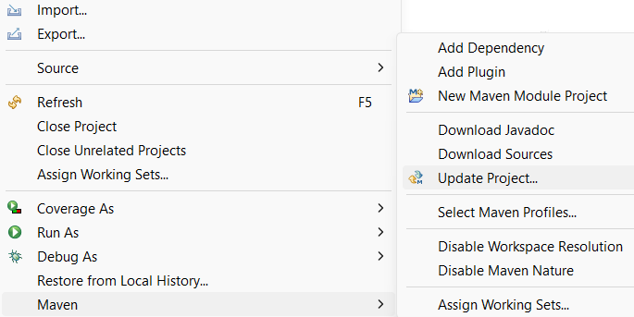
Make sure: Configure the Java Build path
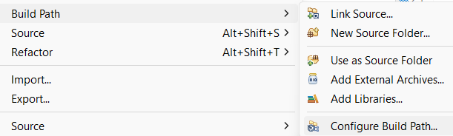
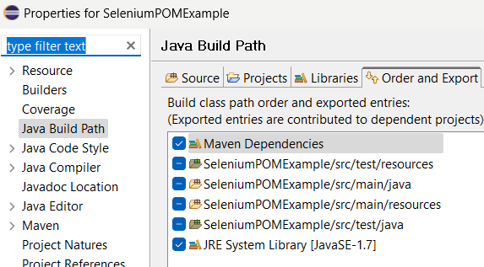

Step 4: Run the Test
- Right-click on the LoginTest class > Run As > JUnit Test

Summary
In this exercise you discovered how to implement the Page Object Model in Selenium using Java and Eclipse. You learned how to structure code, create reusable page objects, and write test cases to interact with a web application.

If time permits

Try the same technique on another site.

